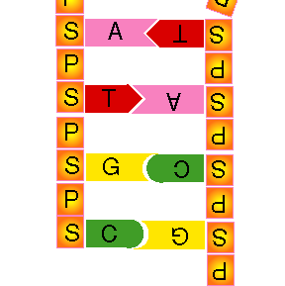
Understanding Genes
Genes, chromosomes, DNA – with so many new words it can be quite hard to understand what they all do. A useful way to think about it is to imagine your DNA as a set of instructions for building you. The instructions won’t fit into one book – we need 46 books (chromosomes) to store all your DNA. Inside each book there are lots of different recipes, or genes. Each gene contains the instructions to make one protein. The instructions are written in a special code that only uses four letters – A, T, C and G
Instructions: Cut out the cards and match the ‘genetics’ idea with the idea from our ‘books’ model.
The Alphabet
ABCDEFGHIJKLMNOP
The DNA code
ABCDEFGHIJKLMNOP

